Name: Tanishka Yagneshwar
Roll Num: 2110110544

Topic: Laundry Management System

Use Case Template: https://online.visual-paradigm.com/community/share/laundry-management-sys-1nhmwcw6yd

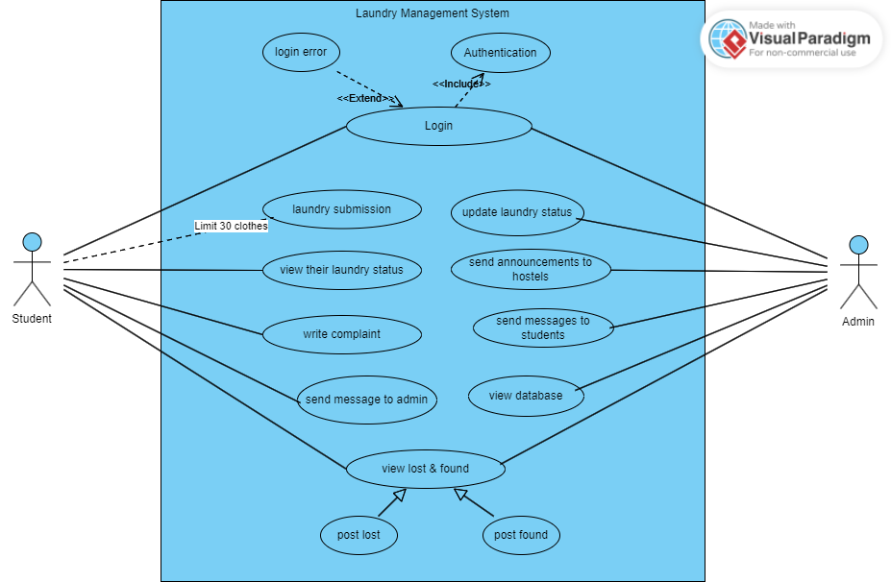

Template:

ID: | 1
Title: | Login
Description: | Used for student and admin login
Primary Actor: | student
Secondary Actor: | admin
Preconditions: | No instance created
Postconditions: | Users sessions started
Dependency | Login error
Generalization | Authentication
Main  Success Scenario: | User logs in successfully after authentication. The respective student or admin portals will open.
Extensions or  Alternate Flow: | If the username or password is wrong then there is a login error
Frequency of Use: | Every time a user logs in
Status: | [Development status]
Owner: | [Who owns this use case, in your project team?]
Priority: | [Priority of this use case]

ID: | 2
Title: | Laundry Submission
Description: | Used for student to five laundry
Primary Actor: | student
Secondary Actor: | admin
Preconditions: | Login done
Postconditions: | Student submits the number of clothes given for laundry
Dependency | Limit 30 clothes
Generalization | none
Main  Success Scenario: | Students submit laundry
Extensions or  Alternate Flow: | none
Frequency of Use: | Whenever user wants to give laundry
Status: | [Development status]
Owner: | [Who owns this use case, in your project team?]
Priority: | [Priority of this use case]

ID: | 3
Title: | View Laundry Status
Description: | Used for student to view the status of their laundry
Primary Actor: | student
Secondary Actor: | admin
Preconditions: | Laundry given
Postconditions: | Student can keep track of their laundry status
Dependency | none
Generalization | none
Main  Success Scenario: | Students see laundry status
Extensions or  Alternate Flow: | none
Frequency of Use: | Whenever user wants to view laundry status
Status: | [Development status]
Owner: | [Who owns this use case, in your project team?]
Priority: | [Priority of this use case]

ID: | 4
Title: | Write Complaint
Description: | Used for student to write complaint to admin
Primary Actor: | student
Secondary Actor: | -
Preconditions: | no
Postconditions: | Gave complaint
Dependency | none
Generalization | none
Main  Success Scenario: | Students can give complaint
Extensions or  Alternate Flow: | none
Frequency of Use: | Whenever they want
Status: | [Development status]
Owner: | [Who owns this use case, in your project team?]
Priority: | [Priority of this use case]

ID: | 5
Title: | Send message to the admin
Description: | Used for students to send message to admin
Primary Actor: | student
Secondary Actor: | -
Preconditions: | no
Postconditions: | Message sent to admin
Dependency | none
Generalization | none
Main  Success Scenario: | Students can send message about a specific laundry item
Extensions or  Alternate Flow: | none
Frequency of Use: | Whenever they submit laundry
Status: | [Development status]
Owner: | [Who owns this use case, in your project team?]
Priority: | [Priority of this use case]

ID: | 6
Title: | Update Laundry Status
Description: | Used for admin to change the status of clothes
Primary Actor: | admin
Secondary Actor: | admin
Preconditions: | When the laundry is under proceedings
Postconditions: | Modifying database status
Dependency | none
Generalization | none
Main  Success Scenario: | Admin can modify the status
Extensions or  Alternate Flow: | none
Frequency of Use: | When the status of the clothes changes
Status: | [Development status]
Owner: | [Who owns this use case, in your project team?]
Priority: | [Priority of this use case]

ID: | 7
Title: | Send announcements to hostels
Description: | Used for admin to send announcements to hostels
Primary Actor: | admin
Secondary Actor: | students
Preconditions: | no
Postconditions: | Gave announcements
Dependency | none
Generalization | none
Main  Success Scenario: | Admin can give announcements
Extensions or  Alternate Flow: | none
Frequency of Use: | Whenever they want to notify something
Status: | [Development status]
Owner: | [Who owns this use case, in your project team?]
Priority: | [Priority of this use case]

ID: | 8
Title: | Send messages to students
Description: | Used for admin to send message to students
Primary Actor: | admin
Secondary Actor: | students
Preconditions: | no
Postconditions: | Give message
Dependency | none
Generalization | none
Main  Success Scenario: | Admin can send messages to students
Extensions or  Alternate Flow: | none
Frequency of Use: | Whenever they want to notify something
Status: | [Development status]
Owner: | [Who owns this use case, in your project team?]
Priority: | [Priority of this use case]

ID: | 9
Title: | View database
Description: | Used for admin to view and modify the database of all laundry
Primary Actor: | admin
Secondary Actor: | admin
Preconditions: | no
Postconditions: | Can view the whole laundry database
Dependency | none
Generalization | none
Main  Success Scenario: | Admin can view and modify the whole database.
Extensions or  Alternate Flow: | none
Frequency of Use: | All the time when the admin makes changes in the laundry status
Status: | [Development status]
Owner: | [Who owns this use case, in your project team?]
Priority: | [Priority of this use case]

ID: | 10
Title: | View Lost & Found
Description: | Used for students and admin to post their lost and found items
Primary Actor: | student
Secondary Actor: | admin
Preconditions: | no
Postconditions: | Posts on lost and found clothes
Dependency | none
Generalization | none
Main  Success Scenario: | Students and admins and click pictures and post lost or found items
Extensions or  Alternate Flow: | none
Frequency of Use: | Whenever they want to post something
Status: | [Development status]
Owner: | [Who owns this use case, in your project team?]
Priority: | [Priority of this use case]

